Create a simple form with validation before submit.
- The simple HTML form shown below consisting of a fieldset, legend, five paragraphs, each paragraph containing a prompt label and a text input field for user input, and ending with submit and reset buttons inside a paragraph element.
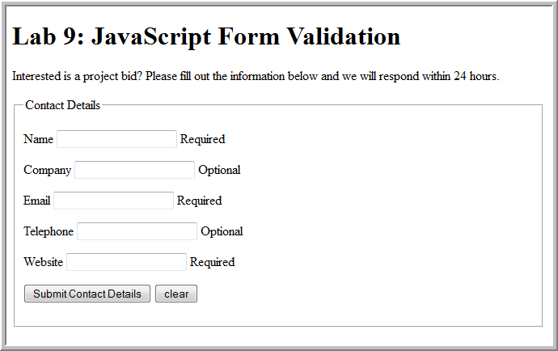

Attach an event handler in JavaScript code
Practice Q1: Attach an event handler to validate the form when the user clicks the submit button [Example given, you have to write one more yourself]
  - JavaScript code given below
window.onload = pageLoad; // global code
// called when page loads; attaches the event handler
function pageLoad() {
var contactForm = document.getElementById("contactForm");
contactForm.onsubmit= validate;
}

Use a JavaScript method to validate for required fields
Practice Q2: Write the JavaScript function validate() that generates a JavaScript alert message "Your name is required" and returns false if the Name text input field has not been filled in, otherwise it returns true.
Tip: document.getElementById may be used to extract the input element and its value property may be used to obtain its value (as a string)
function validate() {
var name = document.getElementById("custname").value;
if (name == "") {
alert("Your name is required");
return false;
}
...
}
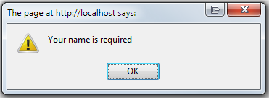
Q3: Add the JavaScript code to make Email and Website required fields and let Company and Telephone be optional fields.
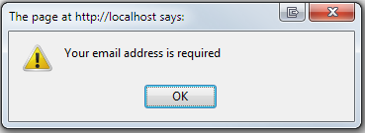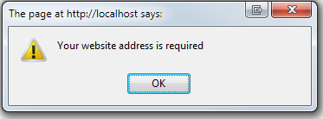

Use regular expressions to validate user input
Q4: Write the JavaScript code that uses a regular expression to validate that the user name consists of only letters or the blank space character. Generate an alert message if the name is incorrect.
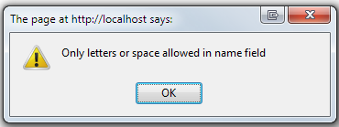
if (!name.match(/^[A-Za-z ]+$/)) {
alert("Only letters or space allowed in name field");
return false;
}
Tip: For help testing regular expressions, visit the Online Regular Expression Tester
Q5: Write the JavaScript code that uses a regular expression to validate that the Email consists aa@bb.cc where aa, bb, and cc are one or more alphanumeric characters.
Q6: Write the JavaScript code that uses a regular expression to validate that the optional Telephone field is in the pattern ddd-ddd-dddd or ddd-dddd where d is any digit
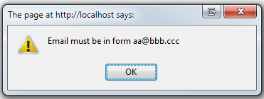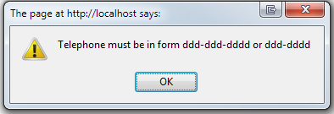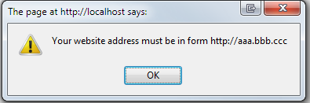

Validate form elements with event handlers
Q8: Add a second form AS GIVEN below AS your contact details form to allow the user to enter project details
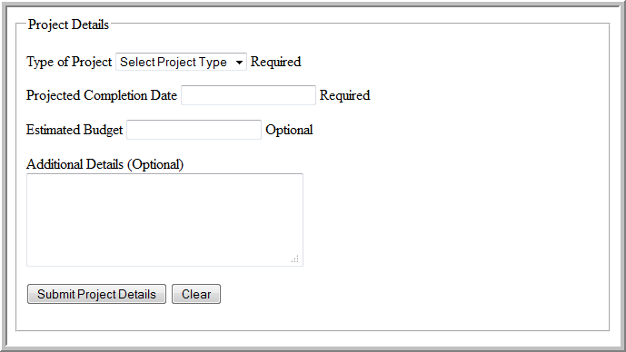
The "Submit Project Details" button is a push button element, not an input element
<button id="submitButton" name="submitButton" type="button" value="submitDetails">
Submit Project Details
</button>
Project Type and Project Completion Date are required, Estimated Budget and Additional Details are optional.

Register event handler functions
Practice Q9: Register four additional event handlers when the page loads to validate the new form elements and handle the button click

document.getElementById(“projectType”).onblur = checkProjectType;
document.getElementById(“completionDate”).onblur = checkDate;
document.getElementById(“budget”).onblur = checkBudget;
document.getElementById(“submitButton”).onclick = submitDetails;

Write event handler functions
Q10: Add four functions to handle the events
- function checkProjectType()
  - if the select projectType's value is "0", show an alert message and return false; otherwise return true
- function checkDate()
  - if the completion date input field's value is empty, show a "date is required" alert message and return false
  - if it does not match the regular expression for "mm/dd/yyyy", show a "date is invalid" alert message and return false
  - otherwise return true
- function checkBudget()
  - if the budget input field's value is empty, return true (budget is optional)
  - if the budget is not a number, show a "budget is invalid" alert message and return false
  - otherwise return true
- function SubmitDetails()
  - if the project type, completion date, and budget are valid, display "Project details submitted" in an alert box; otherwise display the appropriate error

